Elijah Andrushenko

09/06/2018

CPTS 411

Introduction to Parallel Computing

Project Report

The machine used for testing was one of the WSU EECS servers. Specifically ssh7, and it was accessed via putty.

After entering cat /proc/cpuinfo in the command line of the terminal you will see that

•Computer Architecture is x86_64

•Clock Speed is 2200 MHz

•Cache Size is 25600 KB

•Memory Size is 3924048 kB

The result was not what I was expecting. I expected the parallel model to do much better than the serial code. Based on the table below you can see that they are quite similar. There is no clear trend either, neither one is clearly better than the other based on my results. Further testing needs to done as I suspect that I just needed to use bigger data sets to make a better conclusion.

KEY: GREEN = SERIAL CODE RED = PARALLEL MODEL

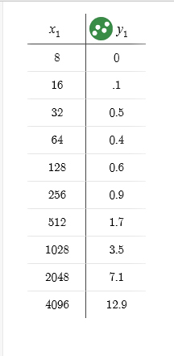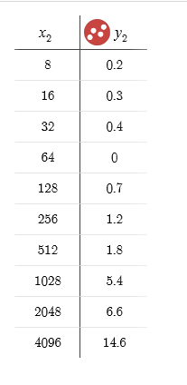

X – Number of Processes or Size of Array

Y – Time Taken to Execute

Source for Time Calculation:

http://www.cs.loyola.edu/~jglenn/702/S2008/Projects/P3/time.html